Chapter 7

Exercise Solutions

Ex 7.1
- 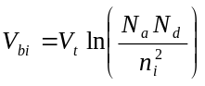
(i) 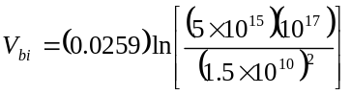
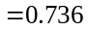V
(ii) 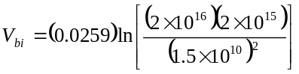
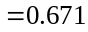V
(b)
(i) 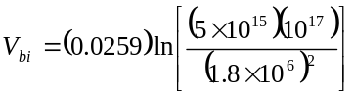
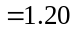V
(ii) 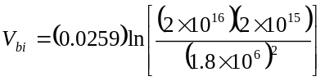
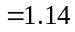V
_______________________________________

Ex 7.2
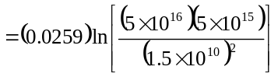
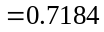V
Then
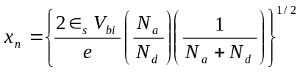
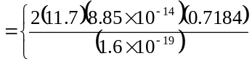
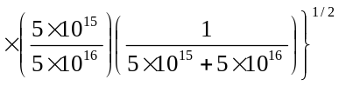
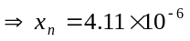cm

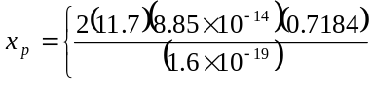
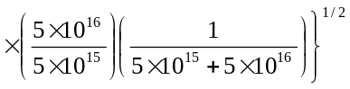
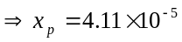cm
Now
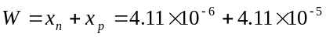
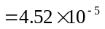cm
Now
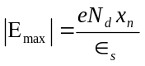
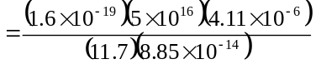
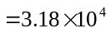V/cm
_______________________________________

Ex 7.3
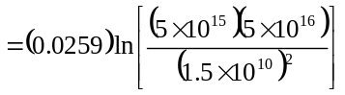
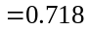V
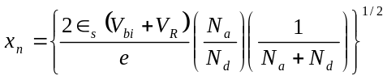
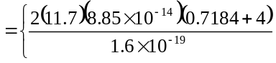
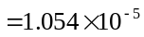cm
or 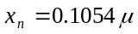m
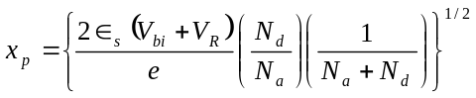
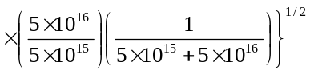
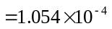cm

or 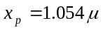m
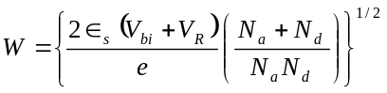
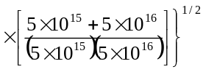
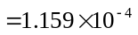cm
or 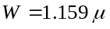m
- 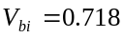V
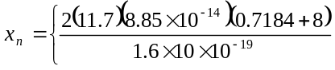
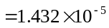cm
or 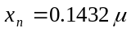m
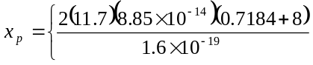
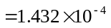cm
or 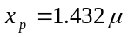m
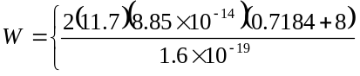
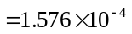cm
or 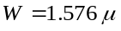m
_______________________________________

Ex 7.4
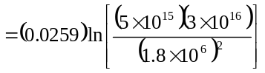
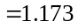V
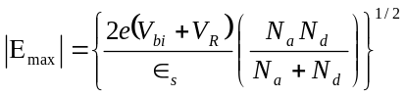

Now 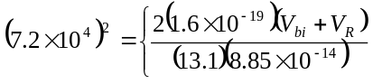
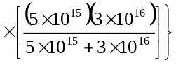
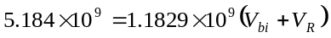
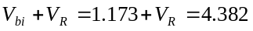
Then 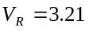V
_______________________________________

Ex 7.5
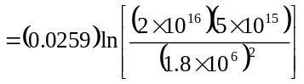
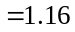V
- 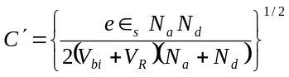
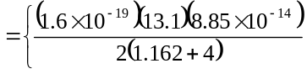
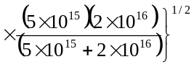
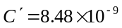F/cm
- 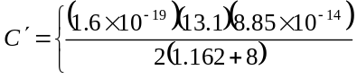
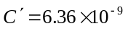F/cm
_______________________________________

Ex 7.6 For a one-sided junction
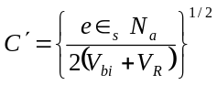
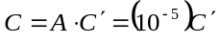
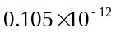
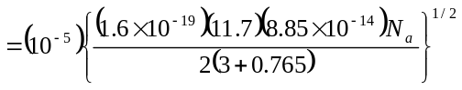
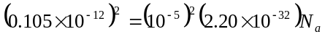
So 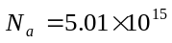cm

We have
Then 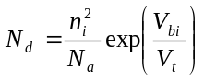
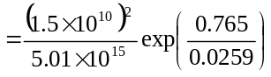
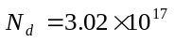cm
_______________________________________

Test Your Understanding Solutions

TYU 7.1
- 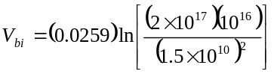
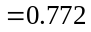V
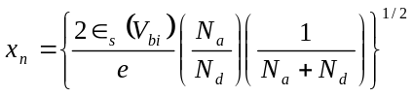
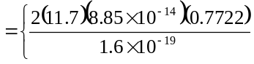
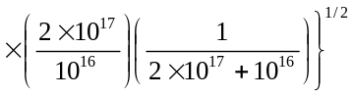
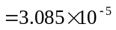cm
or 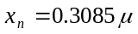m

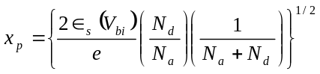
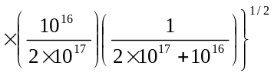
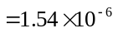cm
or 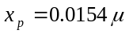m
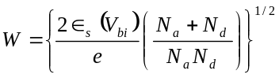
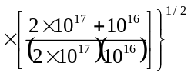

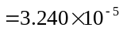cm
or 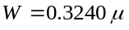m
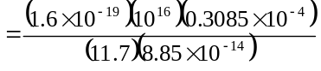
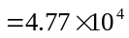V/cm
- 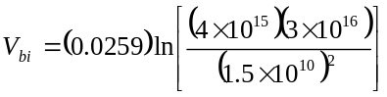
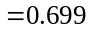V
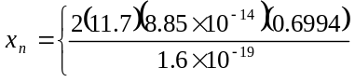
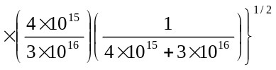
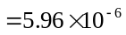cm
or 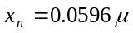m
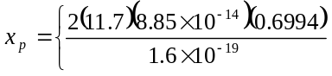
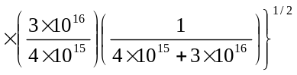
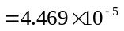cm
or 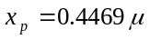m
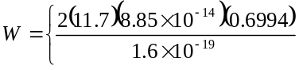
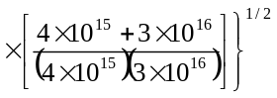
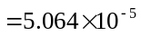cm
or 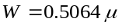m
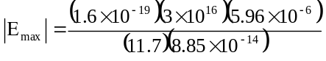
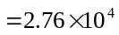V/cm
_______________________________________

TYU 7.2
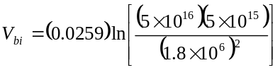
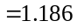V

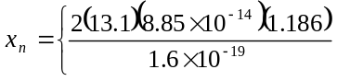
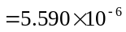cm
or 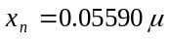m
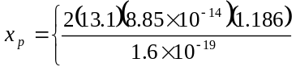
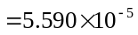cm
or 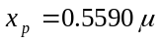m
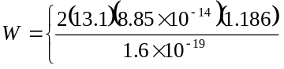
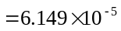cm
or 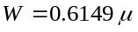m
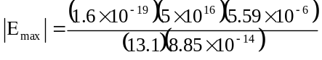
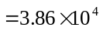V/cm
_______________________________________

TYU 7.3
- 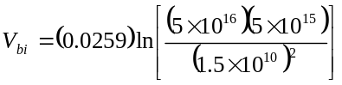
V
Now for 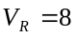V,
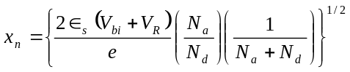
or

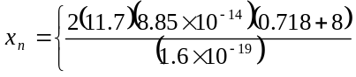
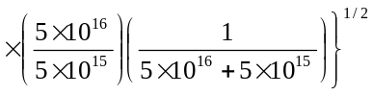
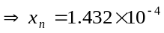cm
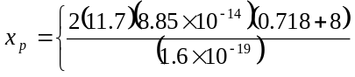
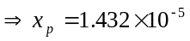cm
Now
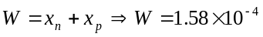cm
Also
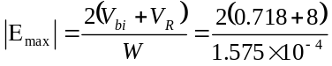
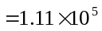V/cm

- For 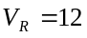V
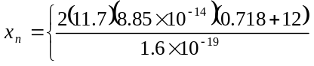
or 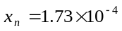cm
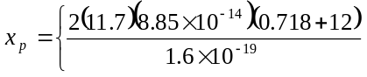
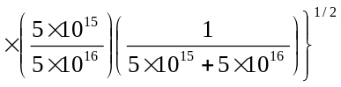
or 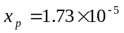cm
Also
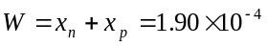cm
Now
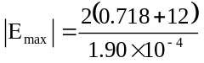
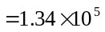V/cm
_______________________________________

TYU 7.4
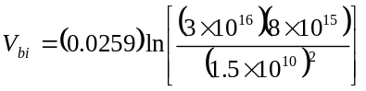
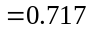V
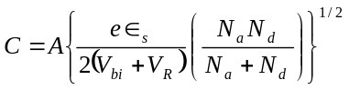
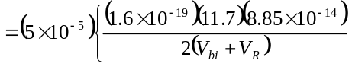
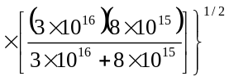
or
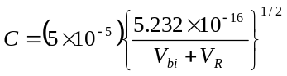
- For 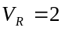V,
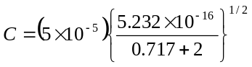
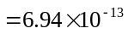F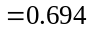pF
- For 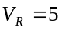V,
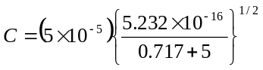
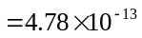F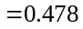pF
_______________________________________

